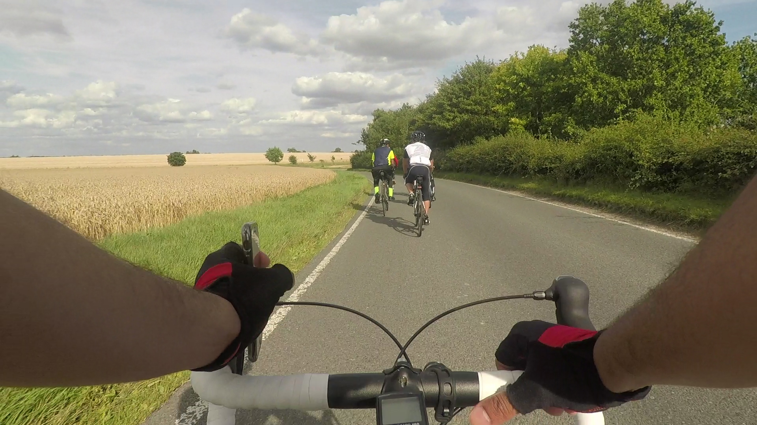
APPLICATION FORM
LEICESTER TO PARIS 2018

Application Form
Please complete the application form to take part in the LEICESTER to PARIS cycle ride on 4th August 2018. All fields are mandatory and once complete please send to ridersofshaam@hotmail.com along with the £300 application fee transferred using the following details Account Number: 34732812 Sort Code: 40-28-06 with reference as ROS2018. For any questions contact us via email: ridersofshaam@hotmail.com or call Amin on: 07545953785. Thank you.
Personal Details
Surname | Click or tap here to enter text. |  | First Name |  |  | Click or tap here to enter text.
Gender | Choose an item. |  | DOB |  |  | Click or tap to enter a date.
Full Address | Click or tap here to enter text. |  |  |  | Postcode |  | Click or tap here to enter text.
Home Tel | Click or tap here to enter text. |  | Mob Tel |  |  | Click or tap here to enter text.
Email | Click or tap here to enter text.
T-shirt size | Choose an item. |  | Jumper Size |  |  |  | Choose an item.
How often do you cycle a week? |  | Choose an item.
What is the name and model of bike you own and is it Road, Hybrid or Mountain?
Click or tap here to enter text.

Emergency Contact Details – 1st point of contact
Full Name | Click or tap here to enter text. | Relationship | Click or tap here to enter text.
Home Telephone | Click or tap here to enter text. | Mobile Telephone | Click or tap here to enter text.
Emergency Contact Details – 2nd point of contact
Full Name | Click or tap here to enter text. | Relationship | Click or tap here to enter text.
Home Telephone | Click or tap here to enter text. | Mobile Telephone | Click or tap here to enter text.

Passport Details
Title | Click or tap here to enter text. | First Name | Click or tap here to enter text.
Middle Name | Click or tap here to enter text. | Last Name | Click or tap here to enter text.
DOB | Click or tap to enter a date. | Nationality | Click or tap here to enter text.
Expiry Date | Click or tap to enter a date. | Passport Number | Click or tap here to enter text.

Medical Declaration (Tick the boxes that apply to you)
Heart trouble and/or blood pressure problems | ☐
Fracture / tendon / ligament / cartilage injury | ☐
Back problems | ☐
Physical or other disability | ☐
Diabetes | ☐
Mental or psychiatric illness | ☐
Epilepsy or fainting | ☐
Hospitalisation in the last 2 years | ☐
Migraine | ☐
Are you suffering from / carrying any contagious diseases | ☐
Severe head injury | ☐
Allergies | ☐
Cancer | ☐
Asthma / bronchitis / shortness of breath | ☐
Are you a smoker? | ☐
Are you on any medication? If so, what are they and state the reasons for taking them
Click or tap here to enter text.

Refunds
Any funds that have been saved from application fees at the end of the trip will either be used by Riders of Shaam for non profit causes or you can choose to have this refunded by completing the following fields.
Please tick the box if you would like Riders of Shaam to refund any funds that have been saved from the application fees. |  |  |  | ☐
Account Number | Click or tap here to enter text. | Sort Code | Click or tap here to enter text.
Taking part in this event you are accepting full responsibility of your own fitness as well as state of health. Doctor’s consent must be provided to prove whether it is okay for you take part in the ride if you have declared any medical conditions to be true.
☐ By ticking this box, you have agreed to the terms and conditions (following page)
Signed
Click or tap here to enter text.
Date
Click or tap to enter a date.

*** All applications are to be submitted with the full amount via BACs transfer to Account Number: 34732812 Sort Code: 40-28-06. Please provide details of your name and a reference as ROS2018. If you have any questions please contact Riders of Shaam through email ridersofshaam@hotmail.com or you can call Amin on 07545953785. Thank you. ***

Terms and Condition
- Every applicant must agree to these terms and conditions to take part in the event. All the terms and conditions must be read before completing the application form.
- Any changes made to these terms and conditions applicants will be notified.
- All applicants must pay the required application fee of £300 when submitting this application form.
- The application form and fee does not guarantee a place on the ride. A screening process will take place either by phone or face to face. When passing this stage all candidates will undergo a series of mandatory training sessions and an assessment of performance and punctuality. Candidates will also be assessed on their commitment to fundraise and contribution to the trip in general. After assessment of the criteria mentioned only then a place is offered to the cyclist.
- Full application fee must be settled when submitting this application form.
- Any applications made after the deadline date, 13th MAY, may not be accepted.
- Any applicants choosing to cancel after the deadline date will lose their full application amount.
- If the refund request has not been completed (for the money saved from the application fees at the end of the trip) will result in applicant’s funds being used by Riders of Shaam for non-profit use.
- Applicants should aim to raise a minimum of £2000.
- Each cyclist is responsible for their own cycle and equipment.
- Only a road or hybrid bike is allowed.
- Cyclists who do not have the minimum safety gear of the equipment highlighted within the information pack will not be able take part in the ride.
- Applicants are joining at a voluntary basis and at their own free will and each cyclist is responsible for their own behaviour and actions.
- If any of the medical conditions apply to you, you must consult a doctor first to see whether the cycle ride is suitable for you. When doing so a doctor's note must be provided.
- Each cyclist must have sufficient knowledge in cycle maintenance (changing a cycle tyre, patching, oiling chains etc).
- All cyclists are responsible for the safety of their own cycle and equipment.
- Any data provided from the application will only be used for the purpose of travel arrangements and will not contravene Data Protection Act 1998.
- Raising money for charity should be out of good intentions and therefore all applicants are recommended to be lawful in collecting and all cash collections must be donated.
- Any cyclist dependent on drugs or alcohol cannot take part in the event.
- Each participant is responsible for carrying out any insurance cover if they choose to. This may include health, accident, lost and returning to the country during the event.
- You must be willing to sleep in difficult and in some cases out of your ordinary living conditions.
- Any additional costs that the trip may occur all applicants must be willing to split the costs equally.
- All information provided on the application form is true and correct.
- All applicants involved will be delegated tasks to carry out. This is to get everyone involved in fundraising activities, promoting the cycle ride, being part of a team and cooperating on the ride.
- This cycle event is a third-party event hosted by Riders of Shaam and has no direct link with The Charity. The charity’s only involvement is to distribute the donations to the chosen projects. Therefore, The Charity is not liable for any actions or behaviour that may cause a negative impact to the charity.
- All applicants must have a valid passport. It is the cyclist’s responsibility to find out details regarding leaving and returning to UK (if they do not have a UK passport).
- It is recommended to carry an EHIC (European Health Insurance Card) which could help with medical treatment for free or at a reduced cost. The EHIC card is free and for more information visit NHS website or visit your local Post Office for an application form.
- Cyclists must attend training sessions prescribed by the Riders of Shaam unless a valid reason has been provided.
- Adequate training and maintenance of health is your own responsibility. If you feel as if you are not capable of participating, please contact the project leader via email or mobile telephone.
- Cyclists must meet at least a 15mph average. Performance will be monitored through Strava.

*** All applications are to be submitted with the full amount via BACs transfer to Account Number: 34732812 Sort Code: 40-28-06. Please provide details of your name and a reference as ROS2018. If you have any questions please contact Riders of Shaam through email ridersofshaam@hotmail.com or you can call Amin on 07545953785. Thank you. ***

